Signup Flow

Stage 1: Account Creation

* Top: Login With Facebook
* Bottom: Signup With LinkMeUp

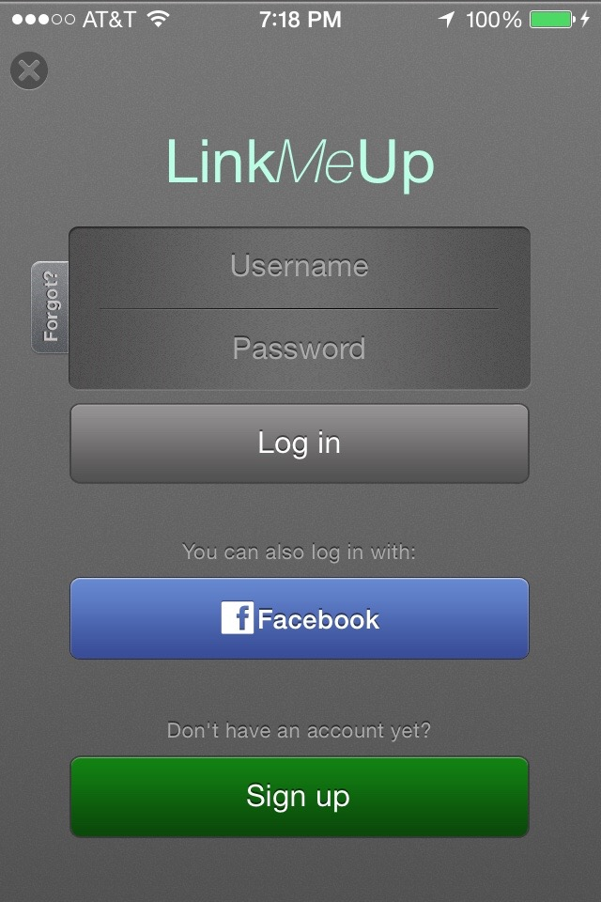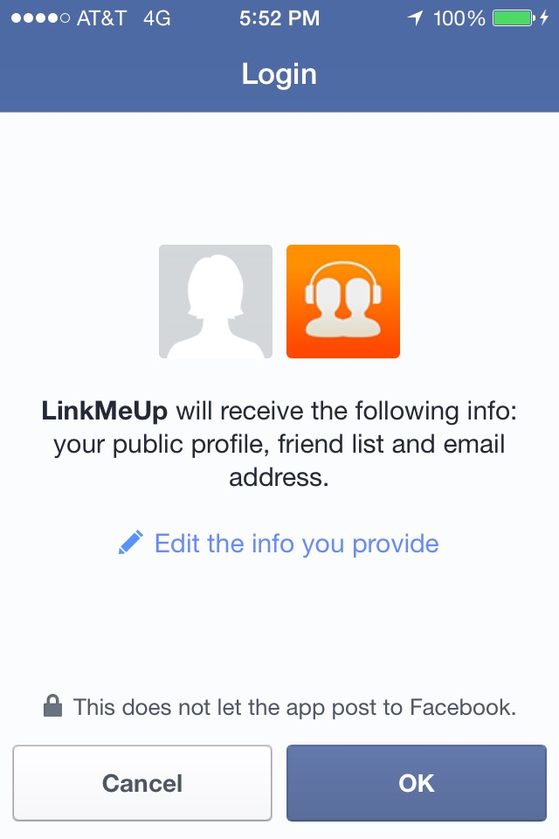

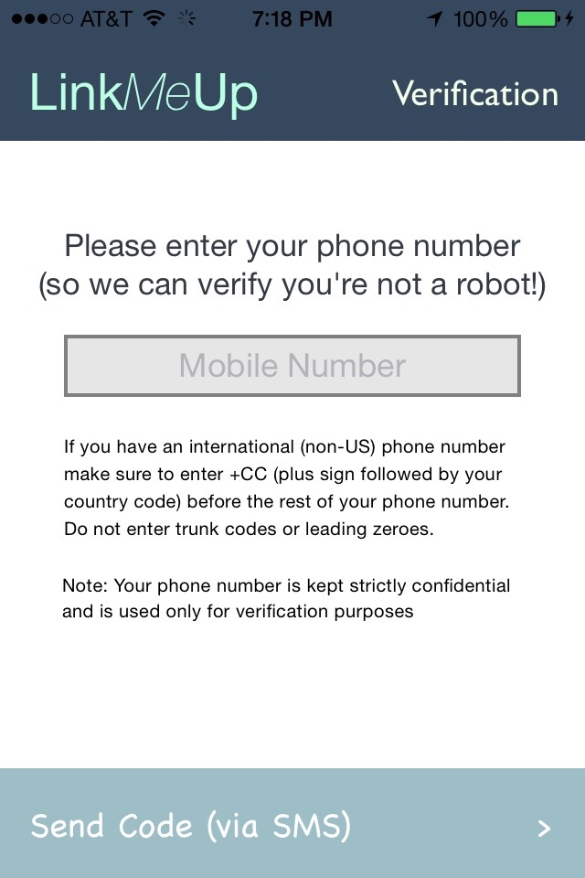

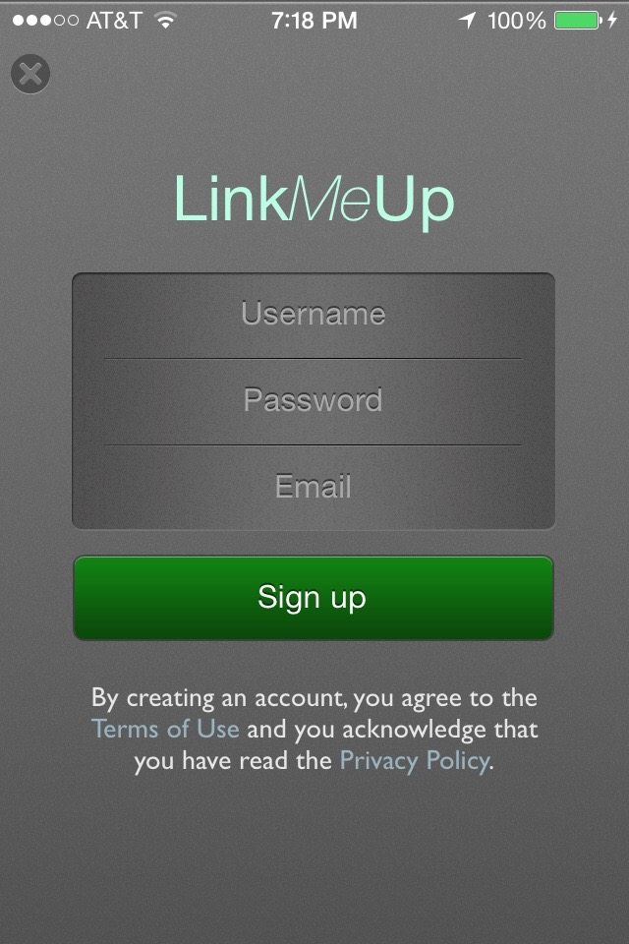

Stage 2: Verification and Launch

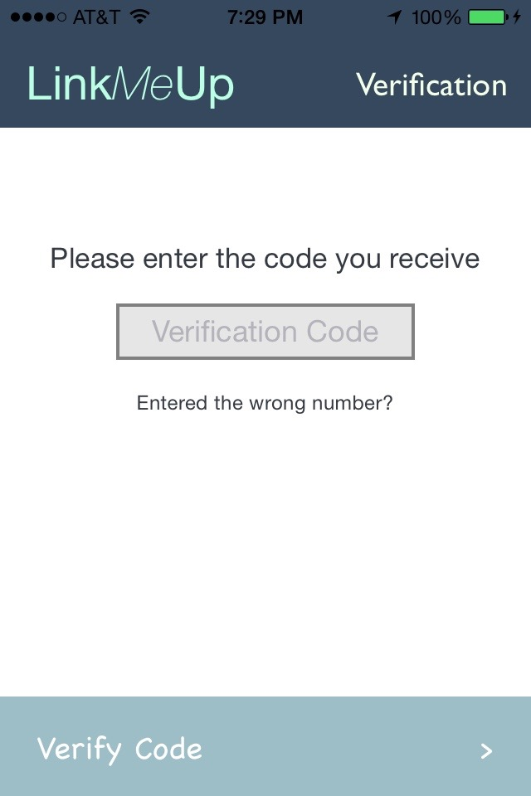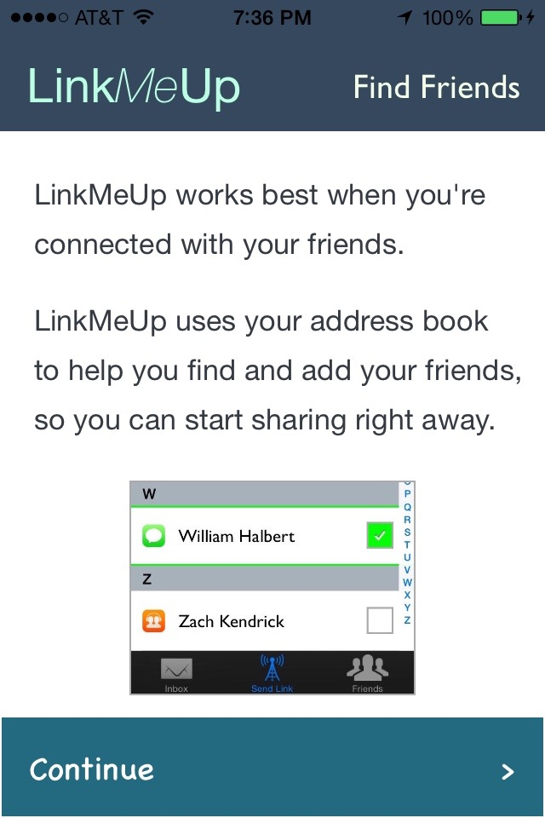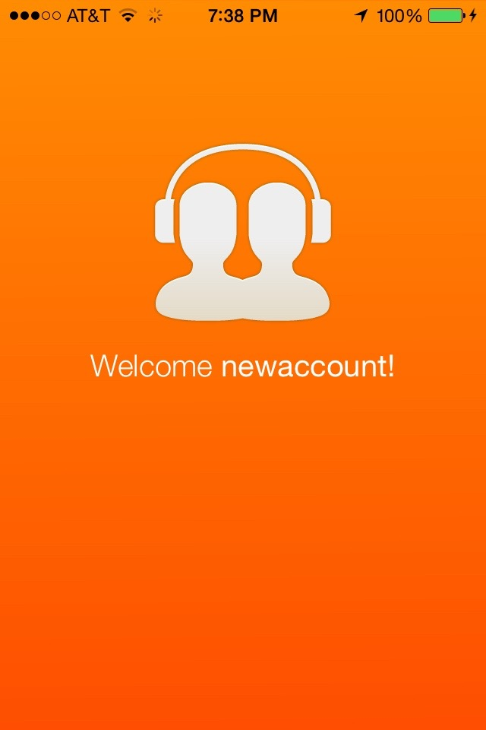

Two ways to create an account

* User presses “Log in with Facebook”
  + User is taken to Facebook app
  + If user agrees to grant requested permissions, control returns to LinkMeUp
    - LogInCallback is called (see ParseLoginFragment.java)
    - Inside callback, if (user is new AND linked with FB)
      * Set local boolean (more on this later)
      * Set username/email/name for user and launch verification
      * See code gist - <https://gist.github.com/SamvitJ/5ec46e6afc28c3fec89b>
        + **Make sure to read this very carefully** – all logic in the gist needs to be included in the Android app
    - Else { existing user is just logging in }
* See User presses “Sign up”
  + SignUpCallback is called
    - Set local boolean (more on this later)
    - Launch verification

Verification and Launch

* Present Enter Number screen
  + Prefill phone number field by reading number from device
  + Note: it may not always be possible to read a phone number from device
* After user presses “Send Code (via SMS)”, change button label to “Verify Code”
  + Check Parse for existing accounts with same phone number
    - If 5 or more existing accounts, display error message "Too many existing accounts linked to this phone number" and return user to Enter Number screen
  + Use Parse Cloud code and Twilio to send SMS with code to user
    - **See my comment on Issue #10 on GitHub for logic**
    - If user enters invalid phone number or some other error occurs, present alert "Oops, something went wrong :(\nTry entering your number again." and take user back to Enter Number screen
  + After user presses “Verify Code”
    - If code is incorrect, present alert "Incorrect Code: Please enter your code again" and take user back to Enter Code screen
    - Otherwise, show Find Friends screen, etc. (the rest is straightforward)

Local boolean – “verification process begun” (see above)

* Parse creates account for user just before LogInCallback/SignUpCallback are called
* If user kills the app before we have verified their number…
  + Next time they open the app, they’ll still be logged in (that’s just how PFUser works)
  + They’ll be able to bypass the verification step – this is a loophole
* We must track if a new user has created an account but not verified their number
  + Set a boolean kDidNotVerifyNumber to true and save in SharedPreferences
  + If user logs in, and this boolean is true, take them to the Enter Number screen
    - Alternative flow: delete their account and take them to login screen